10. Scenario: You are working on a data visualization project and need to create basic plots using

Matplotlib. You have a dataset containing the monthly sales data for a company, including the

month and corresponding sales values. Your task is to develop a Python program that generates line

plots and bar plots to visualize the sales data.

Question:

1. How would you develop a Python program to create a line plot of the monthly sales data?

2: How would you develop a Python program to create a bar plot of the monthly sales data?

**Code:**

**import** pandas **as** pd

**import** matplotlib.pyplot **as** plt

df **=** pd.read_csv(r"C:\Users\vara prasad\Downloads\monthly_sales_data (1).csv")

print("Columns in the DataFrame:", df.columns)

print(df.head())

df['Order Date'] **=** pd.to_datetime(df['Order Date'])

df['Month'] **=** df['Order Date'].dt.month_name()

monthly_sales **=** df.groupby('Month')['Quantity Sold'].sum().reset_index()

*# 1. Line Plot of Monthly Sales*

plt.figure(figsize**=**(10, 5))

plt.plot(monthly_sales['Month'], monthly_sales['Quantity Sold'], marker**=**'o', color**=**'b', linestyle**=**'-', linewidth**=**2, markersize**=**6)

plt.title('Monthly Sales Data - Line Plot')

plt.xlabel('Month')

plt.ylabel('Quantity Sold')

plt.grid(**True**)

plt.xticks(rotation**=**45)

plt.tight_layout()

plt.show()

**output:**

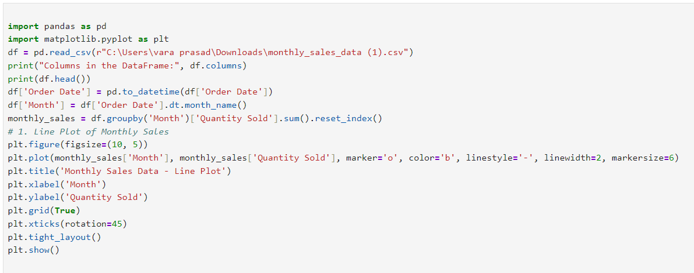

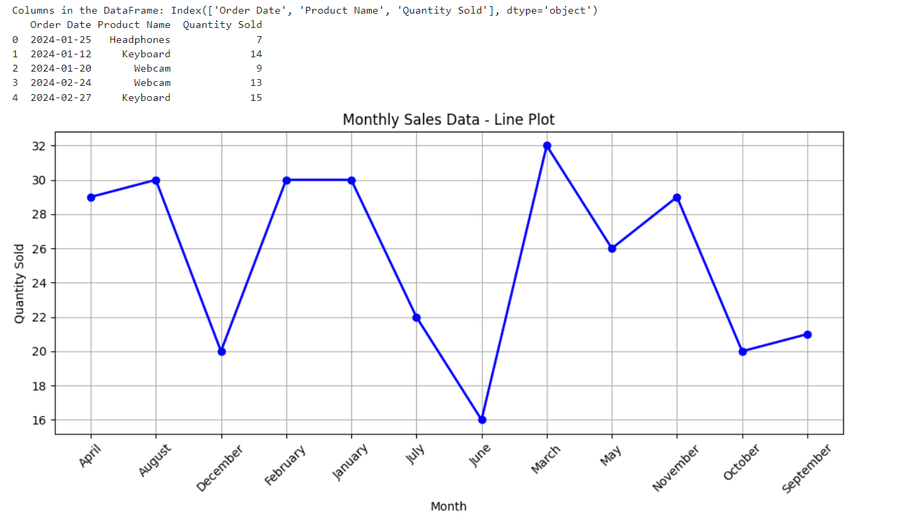

**Dataset:**

|  |  |  |
| --- | --- | --- |
| Order Date | Product Name | Quantity Sold |
| ######## | Headphones | 7 |
| ######## | Keyboard | 14 |
| ######## | Webcam | 9 |
| ######## | Webcam | 13 |
| ######## | Keyboard | 15 |
| ######## | Laptop | 2 |
| ######## | Charger | 5 |
| ######## | Tablet | 13 |
| ######## | Headphones | 14 |
| ######## | Laptop | 10 |
| ######## | Webcam | 7 |
| ######## | Keyboard | 12 |
| ######## | Mouse | 7 |
| ######## | Laptop | 6 |
| ######## | Headphones | 13 |
| ######## | Keyboard | 8 |
| ######## | Headphones | 6 |
| ######## | Laptop | 2 |
| ######## | Mouse | 5 |
| ######## | Monitor | 9 |
| ######## | Webcam | 8 |
| ######## | Tablet | 8 |
| ######## | Keyboard | 13 |
| ######## | Laptop | 9 |
| ######## | Keyboard | 7 |
| ######## | Mouse | 11 |
| ######## | Mouse | 3 |
| ######## | Monitor | 9 |
| ######## | Webcam | 4 |
| ######## | Headphones | 7 |
| ######## | Monitor | 8 |
| ######## | Headphones | 14 |
| ######## | Mouse | 7 |
| ######## | Charger | 4 |
| ######## | Charger | 4 |
| ######## | Charger | 12 |